Computer Engineering Department, S.V.N.I.T. Surat.

B Tech (CO) –IInd Year semester-III

Course: *Data Structures CO203*

**Assignment-VI**

Q1.) Implement double ended priority queue [DeQueue]

The library is managing request for Book in first come first serve manner. Teacher's requests are given higher priority than that of students. Design the task of library using the most suitable Data Structure.

***Code:***

*// Implementation of "Output Restricted Deque"*

*// Insertion from Both Ends, But Deletion from Only One End Based on Priority*

*#include* <stdio.h>

*#include* <conio.h>

*#define* MAX 100

int deque[MAX];

int left = -1, right = -1;

void insert_right(int);

void insert_left(int);

void delete_right(void);

void delete_left(void);

void display(void);

*// Teacher is Inserted from Left & Student is Inserted from Right*

*// Student Request Time Array*

int stime[MAX];

*// Teachers Request Time Array*

int ttime[MAX];

int main()

{

    int i;

    int stud_req = 0;

    int mxn = -1;

    printf("\nEnter the Number of Student Request : ");

    scanf("%d", &stud_req);

*for* (i = 0; i < stud_req; i++)

    {

        printf("Enter Student %d Request Time : ", i + 1);

        scanf("%d", &stime[i]);

*if* (stime[i] > mxn)

            mxn = stime[i];

    }

    int teah_req = 0;

    printf("\nEnter the Number of Teacher Request : ");

    scanf("%d", &teah_req);

*for* (i = 0; i < teah_req; i++)

    {

        printf("Enter Teacher %d Request Time : ", i + 1);

        scanf("%d", &ttime[i]);

*if* (ttime[i] > mxn)

            mxn = ttime[i];

    }

*//Considering Both Student and Teacher Request Time to be Sorted*

*//Student is Inserted from Right*

*for* (i = stud_req - 1; i >= 0; i--)

    {

        insert_right(stime[i]);

    }

*// Teacher is Inserted from Left*

*for* (i = teah_req - 1; i >= 0; i--)

    {

        insert_left(ttime[i]);

    }

*// display();*

    int cur_time;

*// Total Elements in Queue*

    int popcnt = stud_req + teah_req;

    int tcnt = 1;

    int scnt = 1;

    printf("Order of Execution of Request : \n\n");

*if* (stud_req <= 0 && teah_req <= 0)

    {

*if* (stud_req == 0 && teah_req == 0)

        {

            printf("No Request to be Processed!\n");

        }

*else*

        {

            printf("Invalid Input!\n");

        }

*return* 0;

    }

*while* (popcnt != 0)

    {

*// Teacher Request Time*

        int t = deque[left];

*// Student Request Time*

        int s = deque[right];

*if* (t == s)

        {

*// POP Teacher*

*if* (tcnt <= teah_req)

            {

                printf("Teacher %d\n", tcnt);

                tcnt++;

                delete_left();

            }

*else*

            {

                printf("Student %d\n", scnt);

                scnt++;

                delete_right();

            }

        }

*else*

        {

*if* (t < s && tcnt <= teah_req)

            {

*// POP Teacher*

                printf("Teacher %d\n", tcnt);

                tcnt++;

                delete_left();

            }

*else*

            {

*// s < t && scnt<=stud_req*

*// POP Student*

                printf("Student %d\n", scnt);

                scnt++;

                delete_right();

            }

        }

        popcnt--;

    }

*return* 0;

}

*//-------INSERT AT RIGHT-------*

void insert_right(int val)

{

*if* ((left == 0 && right == MAX - 1) || (left == right + 1))

    {

        printf("\nOVERFLOW");

*return*;

    }

*if* (left == -1) *//if queue is initially empty*

    {

        left = 0;

        right = 0;

    }

*else*

    {

*if* (right == MAX - 1)

            right = 0;

*else*

            right = right + 1;

    }

    deque[right] = val;

}

*//-------INSERT AT LEFT-------*

void insert_left(int val)

{

*if* ((left == 0 && right == MAX - 1) || (left == right + 1))

    {

        printf("\nOVERFLOW");

*return*;

    }

*if* (left == -1) *//if queue is initially empty*

    {

        left = 0;

        right = 0;

    }

*else*

    {

*// To Avoid -ve Index in Array*

*// We Insert from Back of deque*

*if* (left == 0)

            left = MAX - 1;

*else*

            left = left - 1;

    }

    deque[left] = val;

}

*//-------DELETE FROM RIGHT-------*

void delete_right()

{

*if* (left == -1)

    {

        printf("\nUNDERFLOW");

*return*;

    }

*// printf("\nThe deleted element is %d\n", deque[right]);*

*// int d = deque[right];*

*//Queue has only one element*

*if* (left == right)

    {

        left = -1;

        right = -1;

    }

*else*

    {

*if* (right == 0)

            right = MAX - 1;

*else*

            right = right - 1;

    }

*return*;

}

*//-------DELETE FROM LEFT-------*

void delete_left()

{

*if* (left == -1)

    {

        printf("\nUNDERFLOW");

*return*;

    }

*// printf("\nThe deleted element is %d\n", deque[left]);*

*// int d = deque[left];*

*if* (left == right) *//Queue has only one element*

    {

        left = -1;

        right = -1;

    }

*else*

    {

*if* (left == MAX - 1)

            left = 0;

*else*

            left = left + 1;

    }

*return*;

}

*//-------DISPLAY-------*

void display()

{

    int front = left, rear = right;

*if* (front == -1)

    {

        printf("\nQueue is Empty\n");

*return*;

    }

    printf("\nDeQueue Elements : ");

*if* (front <= rear)

    {

*while* (front <= rear)

        {

            printf("%d ", deque[front]);

            front++;

        }

    }

*else*

    {

*while* (front <= MAX - 1)

        {

            printf("%d ", deque[front]);

            front++;

        }

        front = 0;

*while* (front <= rear)

        {

            printf("%d ", deque[front]);

            front++;

        }

    }

    printf("\n");

}

***Sample Input:***

(Assuming execution of every request is 1 sec)

Student request at time in seconds: 1,4,6,7,8

Teacher's request at time in seconds: 1,3,5,7,10

***Sample Output*** : [T1->S1-> T2->S2-> T3->S3-> T4->S4-> S5->T5]

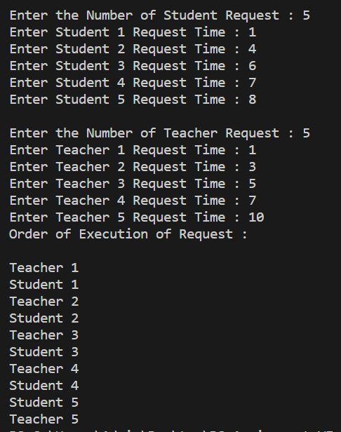

***Sample Input:***

(Assuming execution of every request is 1 sec)

Student request at time in seconds: 1

Teacher's request at time in seconds: 1

***Sample Output*** : [T1->S1]

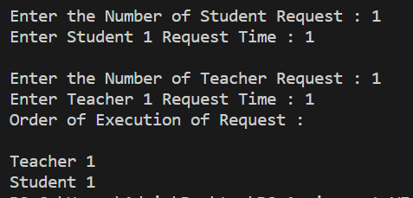

***Sample Input:***

(Assuming execution of every request is 1 sec)

Student request at time in seconds:

Teacher's request at time in seconds:

***Sample Output*** : [No Request]

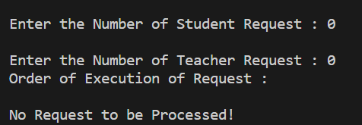

***Sample Input:***

(Assuming execution of every request is 1 sec)

Student request at time in seconds: 2,3

Teacher's request at time in seconds: 1,3,5

***Sample Output*** : [T1->S1-> T2->S2-> T3]

